**Task- 8**

**Aim:** To optimize the Docker image size, consider utilizing Docker Slim or implementing multi-stage builds. These approaches can significantly reduce the container's footprint, enhancing containerization efficiency.

**Step1:** Initially, I created a virtual machine with an image with Ubuntu in the azure In the azure cli

After that, I installed Docker in it

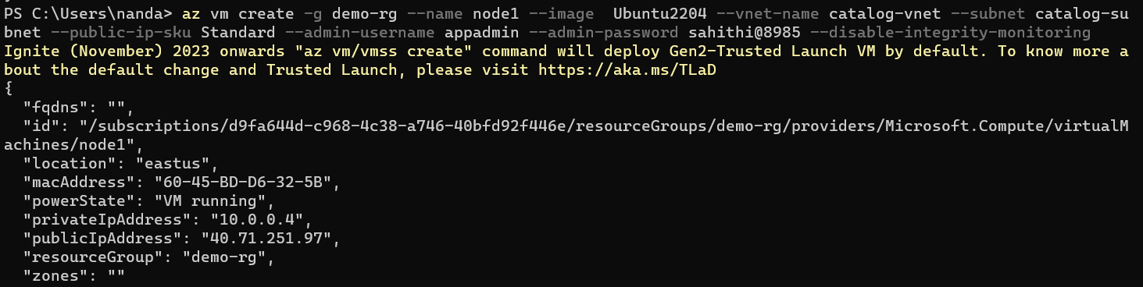

**Step2:** After installing the Docker I tried to create the single stage dockerfile For creating the image By using the below script

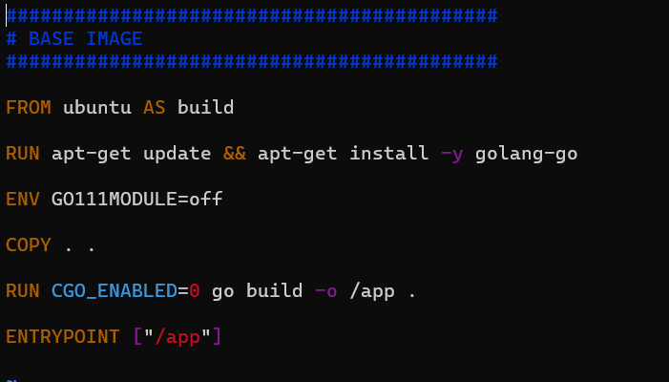

**Step3:** After that, I Created the single stage. I Tried to create the multi stage docker file using two images by using the below script.

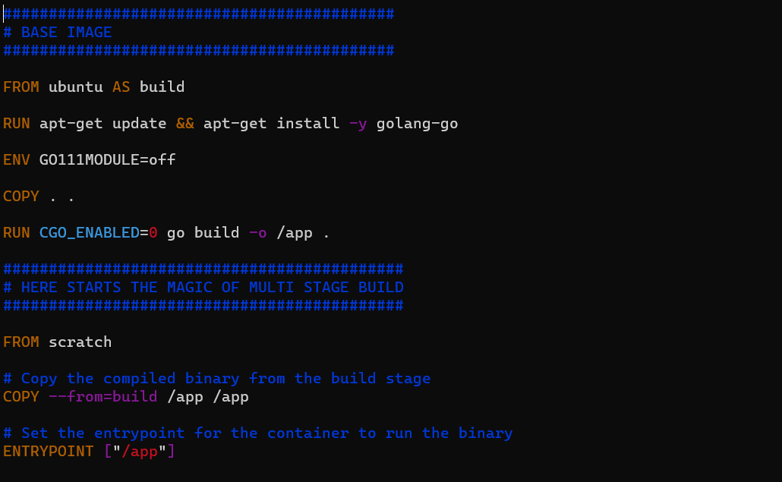

**Step4:** Here you can see that single stage image can occupied 869MB and multistage image occupied 1.83MB space .



I created a virtual machine on Azure running Ubuntu, installed Docker, and created Docker images using single and multi-stage Docker files. The single-stage image occupied 869MB, while the multi-stage image significantly reduced size to 1.83MB, demonstrating the efficiency of multi-stage builds.